|  |
| --- |
| Evaluation Report for Jotter |
| Team Name: Bussin'  Tutorial #1 |
| Tutor: Dominique Chan |

Table of Contents

Introduction 2

The Prototype 3

The Evaluations 3

Executive Summary 4

PART A. USABILITY TESTING **5**

Methodology 5

Results 6

Major Usability Issues 6

Recommendations 8

Improvements of prototype based on recommendations 10

Examples of improvements 10

PART B. USER-EXPERIENCE EVALUATION **13**

Methodology 13

Evaluation Approach 13

Procedure 13

User Experience Stories 13

Results 14

Improvements of prototype based on user experience evaluation recommendations 16

Limitations 18

**PART C. APPENDIX** **19**

Appendix_A Initial Paper Prototypes 19

Appendix_B Initial Digital Designs 20

Appendix_C Jotter Prototype Prior To Testing 21

Appendix_D User Experience Problem Stories 21

Appendix_E Detailed Usability Scenarios 21

Appendix_F User Experience Stories For Evaluation 22

Appendix_G References 22

## Introduction

The aim of the project is to provide a simplistic app that focuses on improving the commuting experience by relieving stress through writing. Personal time can be quite limited from a demanding work or school environment once caught up in the bustling circumstances in life, and results in a lack of engagement with non-work activities that provide recovery. According to a study in 2014, engaging in a creative activity had positive correlations with relaxation experiences and overall performance-related behaviours (Eschleman, Madsen, Alarcon, & Barelka, 2014). The project and our team recognised this need to unwind in many commuters. Thus, this project was created with a focus on providing a creative outlet for users, who commute for long periods of time, to relax.

The solution is an app that primarily focuses on providing users to creatively write as means to relieve stress from their day and concentrate on an activity to get through long commutes. The design solution was determined after conducting first-hand research by interviewing participants based on their commuting experiences.

As the result of first-hand research, this persona was selected to justify the design solution proposed and ensure we had a solid idea of an appropriate target audience. The persona is based on a woman in her early twenties who expresses herself through creative mediums such as writing or photography. The persona is representative of the age group that seeks to try new methods of relaxation and find new fulfilling hobbies. The solution can also be easily expanded to other age groups to capitalise on more users.

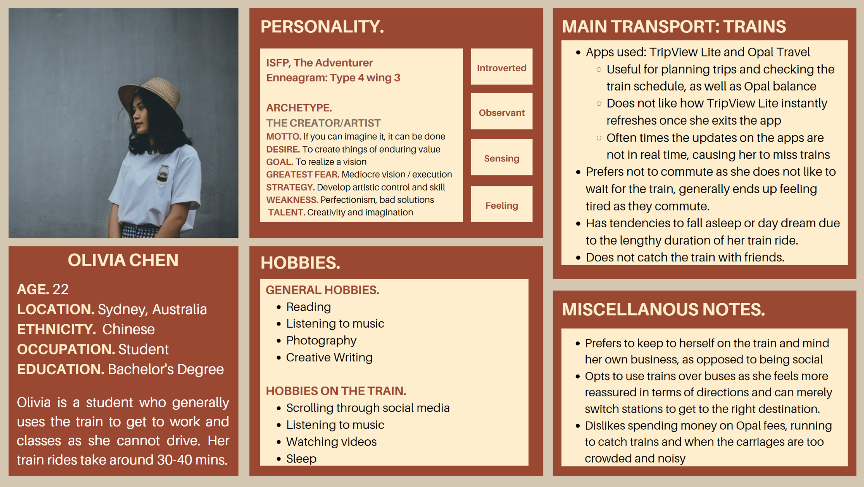

## 

## The Prototype

The prototype in testing is known as Jotter, a mobile app designed to allow users to write stories based on random prompts, the type of which is selected by the user. The app also features account-based functionality, allowing users to save, revisit and continue previously written stories, known colloquially in the app as “Jots”. The app was designed under the notion of being used by public transport commuters on either typically long and boring commutes, based on the commonality of boredom and need for distraction between public transport users interviewed conducted for user research before the design iteration stage. and mainly aims to support commuter relaxation, as well as supporting creativity, expressiveness and comfort.

Initially, the Jotter prototype began as a series of paper prototypes (refer to Appendix_A), exploring potential ideas for wireframing. Alongside these paper prototypes, were also a number of digital designs (refer to Appendix_B) created to assist in visualising and deciding upon the style and aesthetic of the app moving forward. Once these were decided, an interactive wireframe was created on Figma and is currently, prior to evaluations (Refer to Appendix_C), at a stage of medium to high fidelity, with multiple pathways and user interactions established. Based on the requirements illustrated in problem-based user experience stories (refer to Appendix_D), the Jotter app features the ability to:

* Log in to an account
* Create a new Jot with either multiple or no prompts
* Set a timer for how long the user wants to write
* Save a jot
* Access a previously written Jot
* Swapping the app display between light mode and dark mode

All of the above features will be included for user testing. As the prototype is purely wireframe based and features no associated code, the result of some of the featured user interactions are predetermined.

## The Evaluations

To determine the efficacy of the prototype being developed, two types of evaluation will be conducted; usability testing and user-experience evaluation. Through these two evaluation methods, essential information regarding the prototype can be gathered to move forward in terms of enhancing or improving the features presented within the design solution.

Usability testing focuses on presenting the mobile application with multiple users who are unfamiliar with the technology provided to them. This determines the level of ease in regard to navigation and exploration of the application. Conducting these usability tests also enables further observation of what can be improved or enhanced on the prototype’s design or functionality. The results from these usability tests are presented on the major usability issues.

User-experience evaluation focuses on whether the design solution meets the desired needs and experience of relaxation through creative writing. In order to evaluate this aspect, a group member had to roleplay as a user on a long train commute whilst they used the prototype according to user experience stories written by the remaining group members. The results of this evaluation are presented on results within user-experience evaluation.

## Executive Summary

The usability tests took place on testers' own times on their platform of choice, the choice being zoom or discord. As a team, we tested eighteen users to gather sufficient data to ensure our prototype was designed as user friendly and to a high quality degree as much as possible. The first round of usability tests occurred between the 27th September and the 3rd of October. The second round of usability tests occurred the following week from the 4th October to the 9th of October.

The user experience evaluation that the team performed occurred on Discord where screen sharing and camera options were available to ensure a fair and open evaluation that all team members could monitor quietly. The experience evaluation took place at 11:30am on Saturday 9th October with all team members involved. The session ended at 1:00pm the same day.

The results of our testing were mixed in the sense of how to improve our prototype throughout the entire project.

Usability testing results ensured that the prototype was very positive in general as the layout and design was comfortable and familiar to the majority of users. The negative issues, such as certain screen design elements were able to be improved to ensure usability was as high as possible.

The user experience test was very positive in terms of redesigning the layout and elements of the prototype despite some of the feedback.

The user experience tests allowed us to understand the users from the design point of view and correct issues accordingly.

Issues encountered in usability testing and user experience evaluation:

* Covid-19 restrictions
* Acquiring data
* Potential bias from friends/acquaintances during user research
* Online scheduling issues
* Technology issues

# PART A. USABILITY TESTING

## Methodology

**Evaluation Heuristics**

In an effort to ensure a high level of usability, the Jotter prototype was designed with a focus on implementing components and functionality that satisfied the globally-used Usability Heuristics, developed by Danish researcher Jakob Neilson. Not only do these heuristics act as a goal during the iterative design processes, but they also act as a baseline to gauge the usability levels of the prototype during usability testing with external participants. By observing a participant's interactions with the Jotter prototype, testers can uncover both positive or negative findings in relation to each of the ten Usability Heuristics. These findings will then be analysed to provide insight into exactly how the related heuristic was supported or violated, which will be further condensed into recommendations for improvements in the subsequent design interaction.

**Recruitment and Procedure**

The usability testing was completed by 18 participants who were all university students between the age range of 19-22. Due to the COVID-19 pandemic, all the usability testing was conducted through video conferencing via Zoom. Based on the requirements given, all the participants were individually evaluated by a group member with their interviews being recorded for further analysis and observation.

A Zoom link was then presented to the participants where they would be asked prior to the interview for consent to be recorded. This provides assurance and enables the participants to be comfortable with agreeing to being recorded as they have been informed and asked for consent. Once the interview could proceed, a link to the design solution was provided to interact with.

For this procedure, a total of seven scenarios were provided to allow the participants to thoroughly explore and interact with the prototype. During the usability testing, each participant was highly encouraged to use the think-aloud method where they were to express their thought process and what they were doing step by step. This method is a vital aspect of usability testing as it enables further insight into the participants’ feelings and thoughts while they interact with the prototype. Gathering the observations and data made from the think-aloud method and the overall usability testing, enabled the team to recognise which aspects of the prototype needed development or enhancement.

**Evaluation Scenarios**

Evaluation scenarios are an important asset as it allows a deeper understanding of the purpose of the application by allowing participants/testers to actively immerse themselves in it. Full scenarios are referenced in Appendix_E.

Scenarios:

* Create a new jot with no prompts and start writing
  + The expected action from the user when first getting this app
* Create a new jot with prompts and start writing
  + Another expected action from the user when first getting this app
* Continue an old jot
  + The expected action from a somewhat to very experienced user
* Login
  + This was to see how the user would approach logging in.
* Switch between light and dark mode
  + How comfortable was the user with a switch to dark mode located at the bottom right? Having it so easily there was to also see if they would mistap it.
* Create a new jot with no prompts and set a timer
  + How easy was it to create a timer during writing?
* Create a new jot with no prompts and rename a newly created jot
  + How easy was it to rename the jot?

## Results

Overall the interviewees struggled with some of the scenarios and completed some of them with relative ease. From what could be accounted for, the interviewees often needed to get used to the terminology at the start to which to adapt in a rather quick manner. Some glaring usability issues were discovered because of this. The participants speaking aloud their thoughts and actions was a great indicator to see if the current design of the app was suitable or not.

### Major Usability Issues

Task #1: Creating a new jot

|  | Task | Issue | Relevant Heuristic | Severity |
| --- | --- | --- | --- | --- |
| (a) | **Selecting a prompts** | **The prompts option are not split up when the user press one of the prompt it will automatically select all the prompts** | **This violates “User sense of control and freedom” because, at this state the user expects to choose whatever they like, it should not come with another option** | **Critical** |
| (b) | **Start writing with no prompts** | **When the user swipes to the right it displays 6 different prompts that we prepare but empty prompts were not included which confused the user** | **This violates “Visibility of system status” the user expects to see all options even if not show all the options it should guide the user to let them know how to create a jot with no prompts** | **Major** |
| (c) | **Back to the main screen** | **The user has the same problem as in the old jot interface, the user does not know how to go back and what should be the next step** | **This violates ‘Visibility of system status’ as the user was confused at this stage and did not know what to do next.** | **Critical** |
| (d) | **Selecting a prompt** | **When the user presses one of the prompt buttons the feedback was too weak, the user does not even know the button still working or not** | **This violates “Visibility of system status and informative feedback” when the user interacts with the button it does not provide enough visual feedback to let the user notice the interaction was successful or not, so this confused the user as they did not know if the button is working or not.** | **Critical** |
| (e) | **Start writing with prompts** | **The user was initially confused whether there were prompts provided as the text displayed on the design solution was small despite the large empty space provided within the middle of the screen.** | **This violates “Visibility of system status and informative feedback” as the user struggled to read the text as the font was too small. This caused the user to barely notice the prompts provided on the screen.** | **Major** |
| (f) | **Saving the jot** | **The user mentioned that the blue sidebars which function as save buttons drew all their attention as opposed to focusing on the text displayed, such as the prompts.** | **This violates “Visibility of system status and informative feedback” as the user did not initially notice the text displayed on the screen due to their focus immediately shifting to the blue save buttons.** | **Minor** |

Task #2: Continue an old jot

|  | **Task** | **Issue** | **Relevant Heuristic** | **Severity** |
| --- | --- | --- | --- | --- |
| **(a)** | **Back to the main screen** | **When the user was in the old jot there was no ‘back’ button for the user to click, the sidebar was given for the user to swipe left and right but was unclear for the user.** | **This violates “Visibility of system status” the user did not have enough guide for how to go back and the sidebar design was not acceptable** | **Major** |

### 

**Task #3: Login/Setting**

|  | **Task** | **Issue** | **Relevant Heuristic** | **Severity** |
| --- | --- | --- | --- | --- |
| **(a)** | **Login** | **The login function usually displays on the main screen, so it takes a while for the user to find where the login button was.** | **This violates “Visibility of system status” as the login button should be easy to find no user expects that the login function is in the ‘Setting’ menu** | **Minor** |
| **(b)** | **Back to the main screen** | **The user does not know how to return the main screen from the ‘setting menu, the user tries to click on the blank space but it did not work** | **This violates “Visibility of system status”. Clicking the blank space to go back is common interaction logic, so when the user tried the same logic, it did not work and confused the user.** | **Minor** |
| **(c)** | **Setting the timer** | **This timer function was in the writing area, and all the users mentioned they did not even notice a timer function** | **This violates “Visibility of system status”. The user needs a clear guide to notice there is a timer function. The timer design was not good as users did not notice the function. This is due to the visual design being subpar which is why the users could not find it.** | **Minor** |

## Recommendations

Task #1: Creating a new jot

|  | Change | Justification | Severity |
| --- | --- | --- | --- |
| (a) | Allow users to choose whatever prompts they like | This change will improve the user’s experience on the app, it gives back the sense of control and freedom, the user can choose whatever they like and they do not need to worry about selecting the other prompts. | Critical |
| (b) | Add a ‘Blank prompt’ option | This change can give the user a clear understanding of how to create a new job with no prompt, it provides a simple clear guide for the user. so in this way, the user can know what is going on and what to expect | Major |
| (c) | Add a ‘Back’ button | The original design lacked affordances and led to the user being confused about how to “back to the main screen”. Once a ‘back’ button is implemented, this gives the user a clue and allows the user to know how to use it. | Critical |
| (d) | Updated the visual feedback of the buttons | Feedback must be immediate and informative, the feedback for selecting the prompts was not great at the first iteration. This caused confusion as users failed to realise whether they selected anything. The feedback was enhanced to be immediate and information, this ensures that the users know what is happening and what will happen next. | Critical |

Task #2: Continue an old jot

|  | **Change** | **Justification** | **Severity** |
| --- | --- | --- | --- |
| (a) | Add a ‘Back’ button | The user needs to know there is an opportunity to interact, the missing button in the first version confuses the user as they do not know how to go back, adding this button will provide a guide to the user to inform them. | Major |

Task #3: Login/Setting

|  | Change | Justification | Severity |
| --- | --- | --- | --- |
| (a) | Add a ‘Back’ button | This button makes it reasonably predictable as to what will happen next. As a result, there will be no need for the user to guess how to return to the main screen. | Major |

## Improvements of prototype based on recommendations

### Examples of improvements

**Improvement #1: Users can choose whatever they like individually**

During the first iteration, the user had no options to choose the prompts individually as it came with two other prompts. This violates the ‘user sense of control and freedom’ usability heuristic which is a critical issue; it causes the user to feel as if they do not have control with the app due to the inability to choose only one of the prompts provided, this can interfere with the user’s creativity as it forces them to write for two other prompts they would have not chosen in the first place. Users should feel that they are in control of their activities, an aspect that the first iteration lacked and therefore became a usability issue. For the second iteration, this issue was fixed to ensure that the users could choose any of the prompts they wished to write.

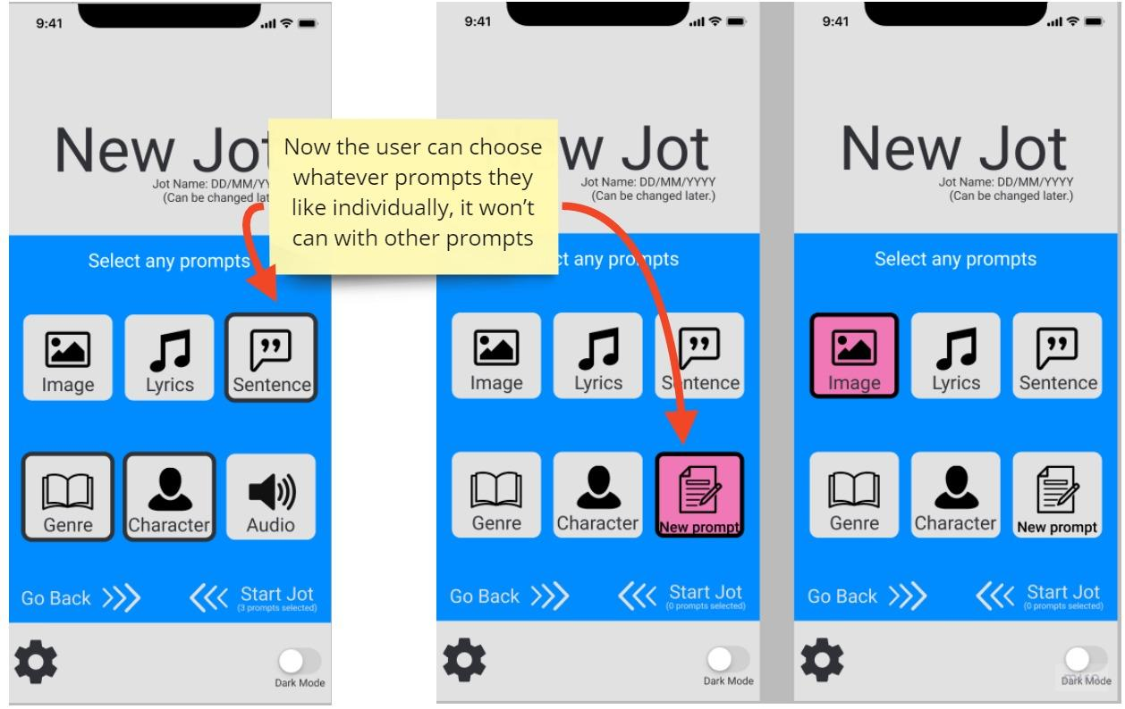

**Fig.1 Creating new jot**

This critical issue has been fixed now. The user could choose whatever prompts they liked individually. This change gave the user a sense of control and freedom; the user commented ‘*I can choose whatever I want individually now!’* and *‘this is how it should be done.’*

**Improvement #2: Updating the visual feedback**

In the first version, it was difficult to determine if the button was selected or not as the sidebar feedback was subpar. When the user clicked the button they did not see any feedback. Feedback should be immediate, informative and needs to tell the user what is the location (‘where am I’), what is the current status (‘what’s happening and is it still happening’), and what is the future status (‘what will happen next’). For the second version of the app, colour was added when the user clicked on it and thickened the border width to ensure the user would not miss it again.

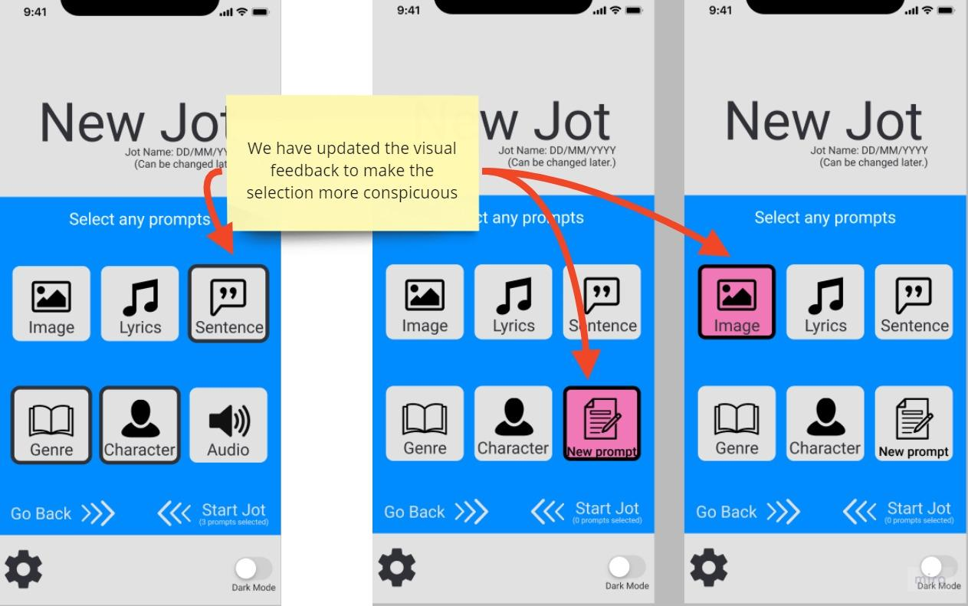

**Fig.2 Visual feedback update**

The new version of usability testing was successful. In the first version, the user struggled to notice whether the button was pressed due to the visual feedback being too muted; the colour and the sidebar bold were not conspicuous, thus the user did not know whether the interaction was successful.

However in the second version, once the user pressed one of the buttons, it was displayed in pink to catch the user’s attention. The bolded border also assisted with garnering attention and no longer violated the ‘visibility of system status and informative feedback’ usability heuristic as it is clear and straightforward. As the user commented, *‘I finally know what I selected.’* and *‘it caught my attention right away.’*

**Improvement #3: Adding a ‘Back’ option**

During the first iteration, the interface lacked affordances and resulted in the user not knowing how to go back. The blue sidebars also did not provide a good affordance. The user had no clue what was the next step and how to get to the next step. Thus for the second version, the writing section was designed more simplistically and implemented a chevron arrow as a ‘back’ function to provide the user a clue on what to do and what is the next step, this ensures the user would not be confused again with this interface.

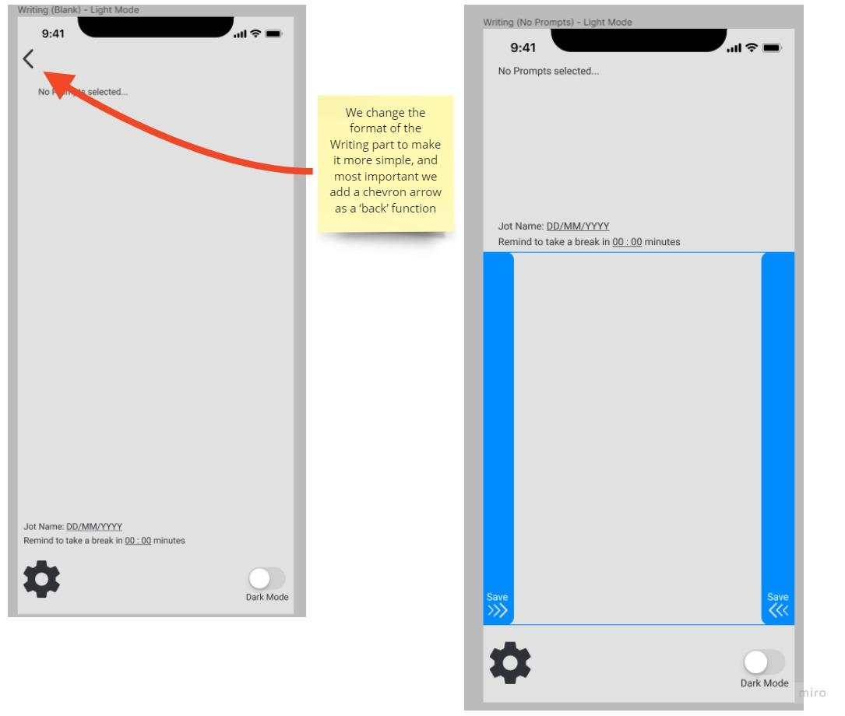

**Fig.3 Writing area**

The improvements made were successful as the user immediately knew where to go back, and fixed the violation of the “visibility of system status” usability heuristic. The user now has a clue on what is going on and knows how to go back, thus regaining a sense of control. This is evident by the user’s comments, *‘[It’s] better than the last version’* and *‘now I know where to go back.’*

# PART B. USER-EXPERIENCE EVALUATION

## Methodology

### Evaluation Approach

The approach used to perform the user-experience evaluation was one of internal testing but from the perspective of the user. One team member undertook the persona we had created and performed the user experience stories that the group members had created prior to the test. This was useful as the team was able to examine the application from the perspective of a user without contacting and testing said users. This ensured we were able to find flaws and problems other users might not find.

### Procedure

This all took place on an online voice call on Discord. The roleplayer screen-shared their interaction with the prototype and turned on their camera for everyone else to take note of the roleplayer's expression during the scenario. In each scenario the roleplayer lasted for at most 5 minutes. During the roleplaying, the person who wrote the scenario is the one that recorded the data by filling in the tables in the Results section.

### User Experience Stories

The following is a short summary of the user experience storyA detailed look at the User Experience stories used for User Experience Evaluation can be found in Appendix_F.

* User Login Experience
  + Highlights the features:
    - Settings
    - Logging in
  + This scenario was created to test how comfortable the user was with accessing the settings overlay and making use of the login feature.
* Creating a new jot with no prompts in dark mode
  + Highlights the features:
    - Creating a new Jot
    - Uses No Prompts
    - Uses dark mode
  + This scenario was created under the idea the user used it not for writing but for just jotting down ideas
* Creating a new jot with prompts
  + Highlights the features:
    - Creating a new Jot
    - Uses Prompts
  + This scenario was created to observe the experience of creating a jot with a prompt and how this would affect writing.
* Finding comfort in an old jot
  + Highlights the features:
    - Logging in
    - Accessing an Old Jot
    - Favourites
  + This scenario was created to observe the user’s experience with the old jot screen, particularly finding a specific story and accessing it.
* Create a new jot with no prompts and set a time
  + Highlights the features:
    - Creating a new jot with no prompts
    - Setting a timer
  + This scenario was created to observe the user’s experience with writing a new jot in a situation with a time constraint, for example, not wanting to miss their destination on the train.

## Results

Through observation, the main user experiences were mostly positive. This leads to the quality of the user experience as mainly positive. Because both the main and quality of the user experiences were positive, there were little to no recommendations to improve from it.

User Login Experience

| **Phases** | **Main user experiences** | **Quality of user experiences** | **Recommendations** |
| --- | --- | --- | --- |
| Title Screen | Observing the options, calming down upon viewing the title screen | Very positive | N/A |
| Options | Satisfied about the speed of the app, relaxing slightly | Very positive | N/A |
| Login Screen | Doesn’t want to sign in with anything other than Google, happy it is working as intended | Very positive | N/A |
| Success | Happy that the feature works correctly, doesn’t know how to exit | Mostly positive | Create a home page button or a login button instead of settings |

Creating a new jot with no prompts in dark mode

| **Phases** | **Main user experiences** | **Quality of user experiences** | **Recommendations** |
| --- | --- | --- | --- |
| Title Screen | Very familiar with this type of screen | desirable | N/A |
| New Jot Screen | Enjoyed the swipe interaction | desirable | N/A |
| Writing Screen | Excited that she was able to start the writing quickie | desirable | N/A |

Creating a new jot with no prompts and jotting down ideas in dark mode

| **Phases** | **Main user experiences** | **Quality of user experiences** | **Recommendations** |
| --- | --- | --- | --- |
| Switching to dark mode | Familiar with what to do | Satisfied | N/A |
| Selecting prompts in the New Jot Screen | Familiar with what to do | Satisfied | N/A |
| Writing Screen | Familiar with what to do | Satisfied | N/A |

Finding comfort in an old jot

| **Phases** | **Main user experiences** | **Quality of user experiences** | **Recommendations** |
| --- | --- | --- | --- |
| Logging in | Bored | Neutral | N/A |
| Returning to Home screen | Confusion | Negative | Remove the settings menu and replace it with a dedicated login button. |
| Accessing the old jot | Joy | Positive | N/A |
| Reading the old jot | Joy | Positive | N/A |

Create a new jot with no prompts and set a time

| **Phases** | **Main user experiences** | **Quality of user experiences** | **Recommendations** |
| --- | --- | --- | --- |
| Title Screen | Familiar with what to do and navigation | Neutral | N/A |
| New Jot Screen | Familiar with what to do and navigation | Comfortable | N/A |
| Writing Screen | Familiar with what to do and navigation | Excitement | N/A |
| Timer | Struggles to see where the timer is and takes a few seconds to locate the timer, feels joy once the timer has been set | Frustration, joy | Relocate the timer feature where it is more visible and provide another affordance as opposed to text only |

## Improvements of prototype based on user experience evaluation recommendations

**Improvement #1: Changing the login icon to make sure the user find where to login**

In the first version of usability testing, most of the users said they couldn’t find the login function; it was because the login function was in the ‘setting’ button, and it confused most of the users they won’t expect the login function in the ‘setting’ button because this is not the past experience tell them. So in the second version, the ‘setting’ button was changed to the ‘profile’ icon, which indicates a login function. There’s even a word down below to give clear affordances. The image(fig. 4) shows the new version and the old version.

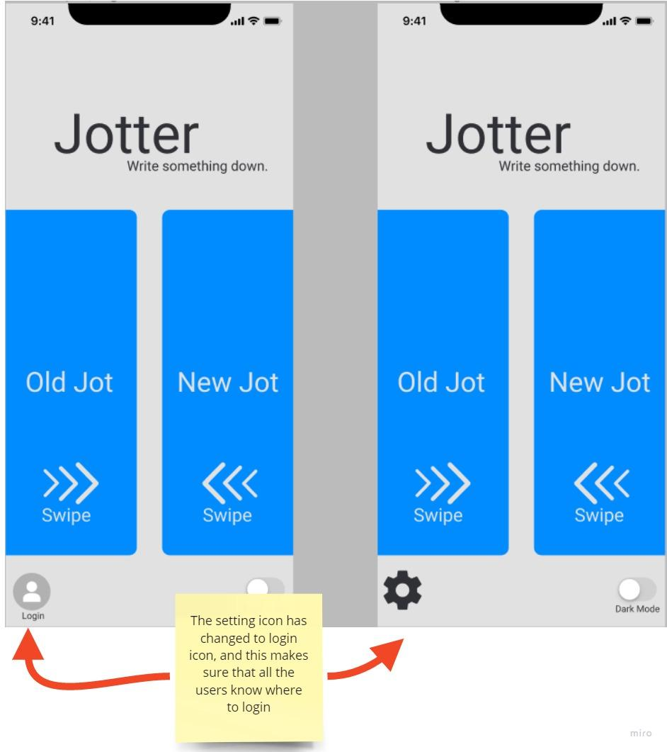

**Fig.4 Starting screen (New)**

**Improvement #2: Adding a timer icon to let the user notice the function**

In the first version of the design, the user doesn’t even notice there’s a timer function because the guide was too weak, and the timer function was not in the central area, so it was hard to realize there’s a timer function. But in the second version, the timer function has become a button. It is next to the ‘dark mode’ button; in this way, the user’s attention will be caught right away; this simple timer guide helps the user to notice this function.

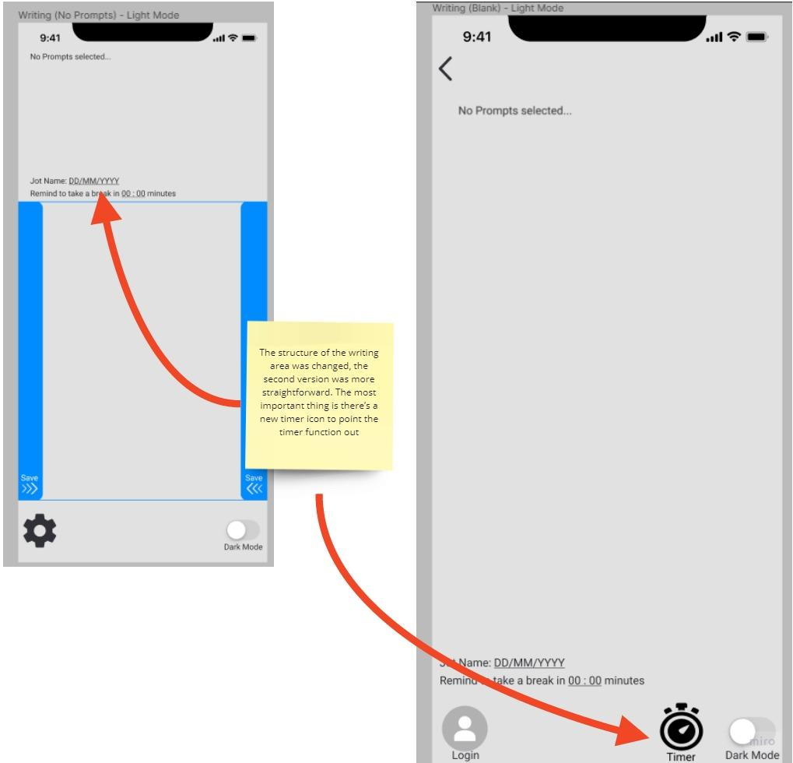

**Fig 5. Writing area with a timer**

## 

## Limitations

The main limitation that impacted the entire project was the effect of the COVID-19 pandemic which caused the process of planning, developing and testing the design solution to be conducted online. Due to this limitation, usability testing with participants were held through video conferencing which resulted in general issues such as online scheduling or rescheduling, having to view others through a camera, setting up and using technology to achieve the testing, etc. This mainly impacted the usability evaluation in terms of contacting and conducting tests with users outside the team, and as the completion time of user testing varied across the group, this meant that little to no progress could be made for the evaluation report until every member of the group had done their required number of user testing.

However, the user experience evaluation suffered less from these issues as it was kept within the team and completed in a controlled environment. Due to the time frame, the user experience evaluation was done immediately after the completion of the second round of usability testing, and was also conducted online. This could have a possible impact in terms of accuracy and authenticity on the results as the evaluation could not be accomplished in the intended environment.

The results, however, have little to no limitations as it mainly exists in terms of acquiring data from test users. Although the sample data is rather small, it was large enough to conduct comprehensive testing and gain notable information essential for improvements. Despite the successful outcomes from the sample size, it is important to note the possibility of bias during the acquisition of data from participants, specifically in-group biases. In-group bias is the tendency of giving preferential treatment to those who belong in the same group, and can also result in the possibility of perceiving the same behaviours (The Decision Lab, n.d.). Seeing that every member of the team interviewed a friend or acquaintance, there could be a chance of in-group biases occurring which could have impacted the results garnered from the participants while they expressed their opinions and thoughts about the design solution presented during the usability testing.

# 

# PART C. APPENDIX

## Appendix_A Initial Paper Prototypes

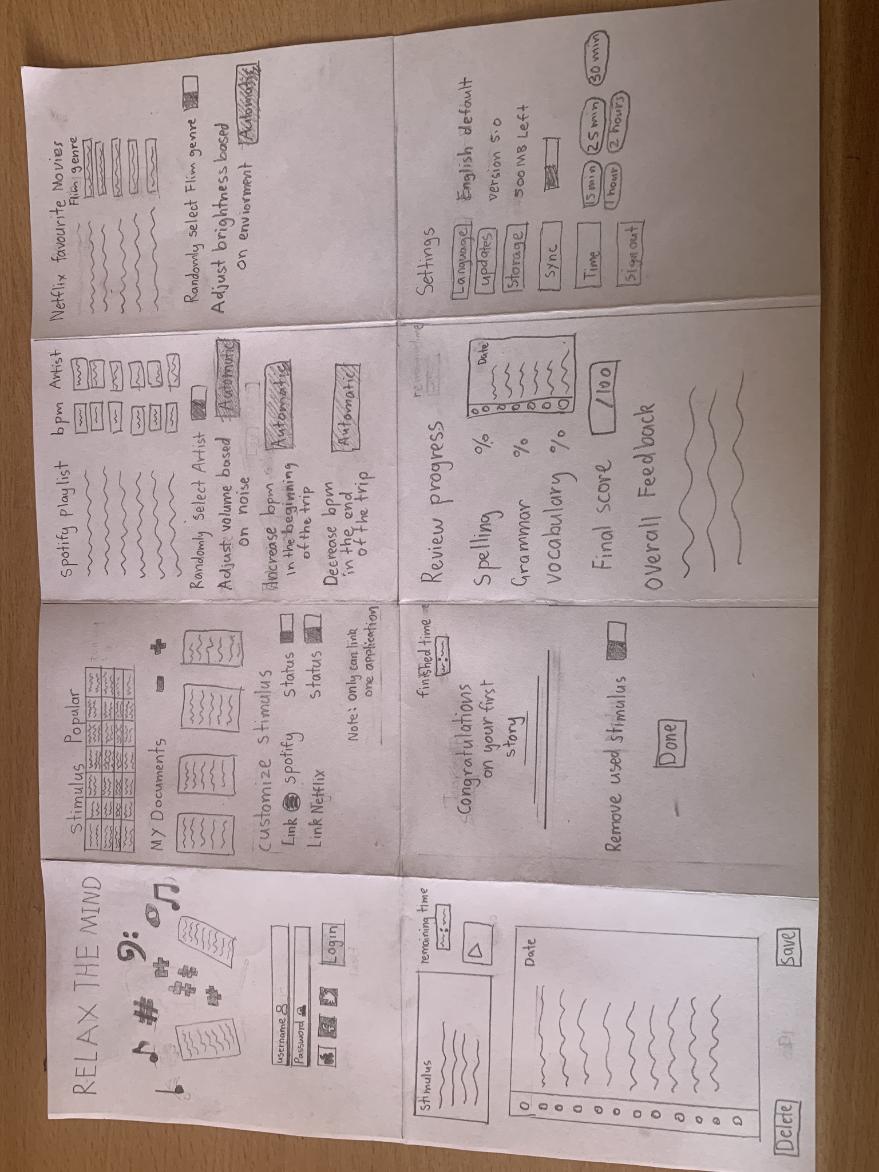

## Appendix_B Initial Digital Designs

|  |  |  |
| --- | --- | --- |

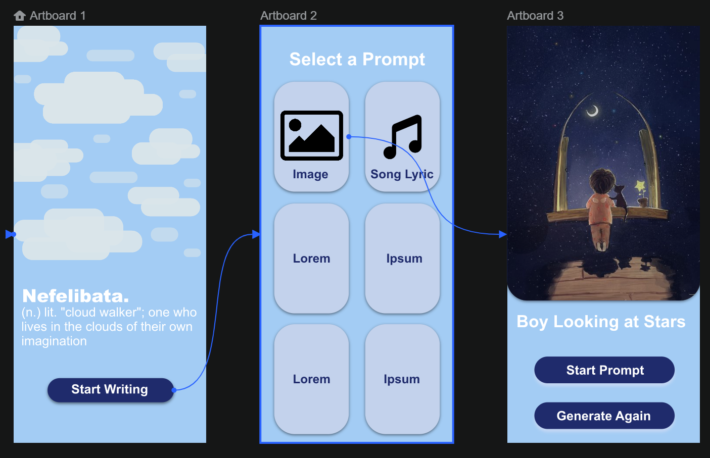

## Appendix_C Jotter Prototype Prior To Testing

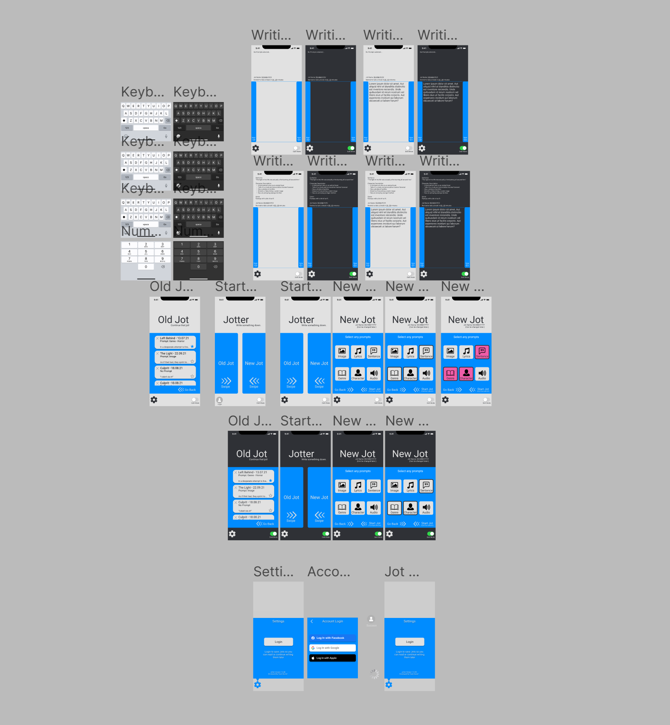

## Appendix_D User Experience Problem Stories

[Problem UX Stories](https://docs.google.com/document/d/16KLY1_yIOZeRTJSoFXpH7NxftqWh_rrAtVEXGAN6AlY/edit?usp=sharing)

## 

## Appendix_E Detailed Usability Scenarios

[Evaluation Scenarios](https://docs.google.com/document/d/1tLTQu6jcsTHOuloh8Q1ESqPEhG9s5IrB2p_7HF-svvY/edit)

## 

## Appendix_F User Experience Stories For Evaluation

[UX Stories for Evaluation](https://docs.google.com/document/d/1DoRp-p38_un2Xgg0jWtG2-GaoiAB5G2Z/edit?usp=sharing&ouid=114029560767222829038&rtpof=true&sd=true)

## Appendix_G References

Eschleman, K., Madsen, J., Alarcon, G., & Barelka, A. (2014). Benefiting from creative activity: The positive relationships between creative activity, recovery experiences, and performance-related outcomes. Journal of occupational and organizational psychology, Vol..87 (3), p.579-598.

<https://doi.org/10.1111/joop.12064>

The Decision Lab. (n.d.). Why do we treat our in-group better than we do our out-group? The Decision Lab.

<https://thedecisionlab.com/biases/in-group-bias/>